**Daniil Skvyrskyi**

1. *SecurityDevice.java (implemented using Java):*

The engine is fed numbers one by one. Each additional digit is added to the existing sequence of digits once it has been entered, which is then checked for the unlock or lock code and cleared of any non-integer values. When one of the codes is found, the machine's state is modified in relation to that code. The state diagram is shown below.

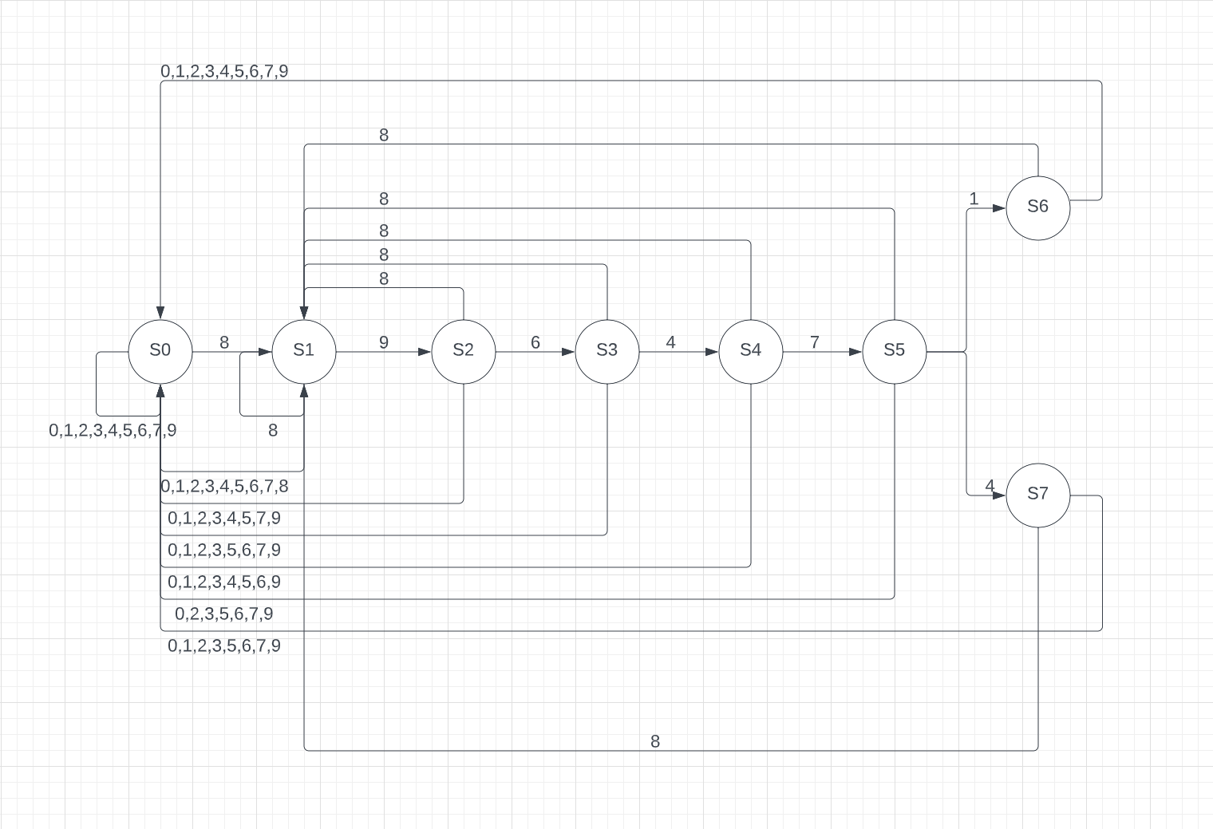

*Figure 1: State Diagram*

1. *testrandom.java* :

If you want to guess a 6 digits code you will go from 000000 to 999999. Assuming that each try takes 1 second, the worst-case scenario is 999999 seconds which is about 228 hours of guessing to unlock a lock. The probability to guess a code is $(1/10)^{6}$ (using Bernoulli’s formula).

Instead of a user-typed digit, a random number is created and entered into the engine to imitate this. Every time a random digit is entered, all earlier digits are added to the sequence and used to search for the unlock code. Another digit is created and entered if that code is missing. This keeps happening until the sequence has the correct unlock code.

Sample output using 20 trials:

